Child Care Capacity Building Opportunity
Proposal Summary Form

Applicant Information | ☐ Individual  ☐ Organization/Entity
Applicant Name | Click or tap here to enter text.
Geographic Area  (ie. Community Name or County Name) | Click or tap here to enter text.
How many capacity expansion projects would be supported through these funds | Click or tap here to enter text.
Proposed Project | ☐ Renovation  ☐ New Construction  ☐ Other: Click or tap here to enter text.

Please indicate which of the funding specifications this proposal fulfills: (may select more than one if there is more than one project)

☐New/not yet licensed program
☐Family Child Care Home I
☐Family Child Care Home II
☐Child Care Center
☐Current license expanding from (enter number) to
☐Expanding license from a Family Child Care Home I to a Family Child Care Home II
☐Expanding license from a Family Child Care Home I to a Child Care Center
☐Expanding license from a Family Child Care Home II to a Child Care Center
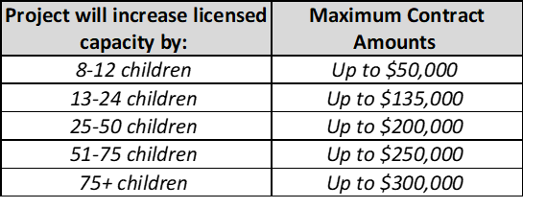
Total ARPA Funds Requested (to be spent by June 30, 2023): $ Click or tap here to enter text.

Total overall cost of expansion project(s):
$ Click or tap here to enter text.
*This is the overall cost of the development or expansion project(s).

